What is Really Happening in Syria Today?
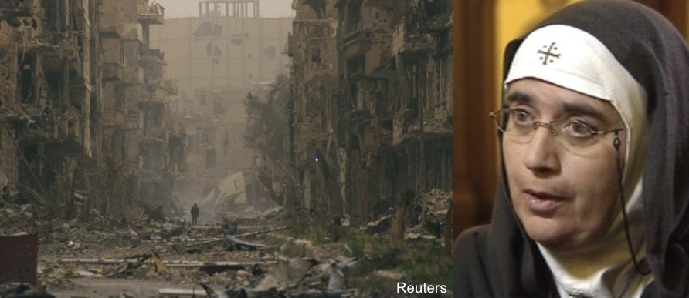
Mother Agnes-Mariam of the Cross is Mother Superior at the Monastery and Convent of St. James in Qara, Syria. Much of the population in the towns and villages around the monastery have fled and been made refugees. Gunmen attacked her vehicle in May, 2013.
The story that Mother Agnes tells is very different from what we hear and read in the North American press. In Spring 2013 she organized an international delegation, led by Nobel Peace Laureate Mairead Maguire, which visited Lebanon and Syria. The delegation observed conditions and talked with refugees, opposition and government representatives. Mother Agnes is one of the main organizers of Mussalaha (“Reconciliation”) Initiative, a popular movement in Syria that mediates disputes and organizes ceasefires between opposing forces.
Mother Agnes is touring the U.S. and Canada in November and December 2013 to inform people about the reality in Syria and the need to stop foreign support and financing of terrorism. Her message is non-sectarian, promoting the values of Peace, Love and Reconciliation.
CURRENTLY SCHEDULED SF BAY AREA PUBLIC EVENTS
(see website for latest schedule)

Sunday, Nov 3 at 5:30 PM, St. Thomas More Church
1300 Junipero Serra Blvd. at Brotherhood and Thomas More Ways, San Francisco

Tuesday, Nov 5 at 4:00 PM, Creekside Room, 1010 Stanley Dollar Drive, Walnut Creek (Rossmoor)

Wednesday, Nov 6 at 7:00 pm, Our Lady of Grace Church, Stack Hall, 3433 Somerset, Castro Valley

Thursday, Nov 7 at 7:00 pm, First Christian Church of Oakland/Oakland Peace Center, 111 Fairmount Ave/ 259 29th Street (two blocks from Broadway and 29th), Oakland.

Syria Solidarity Movement / 510-232-2500
Email: solidarity@syriasolidaritymovement.org
Website: www.syriasolidaritymovement.org

